Part 1
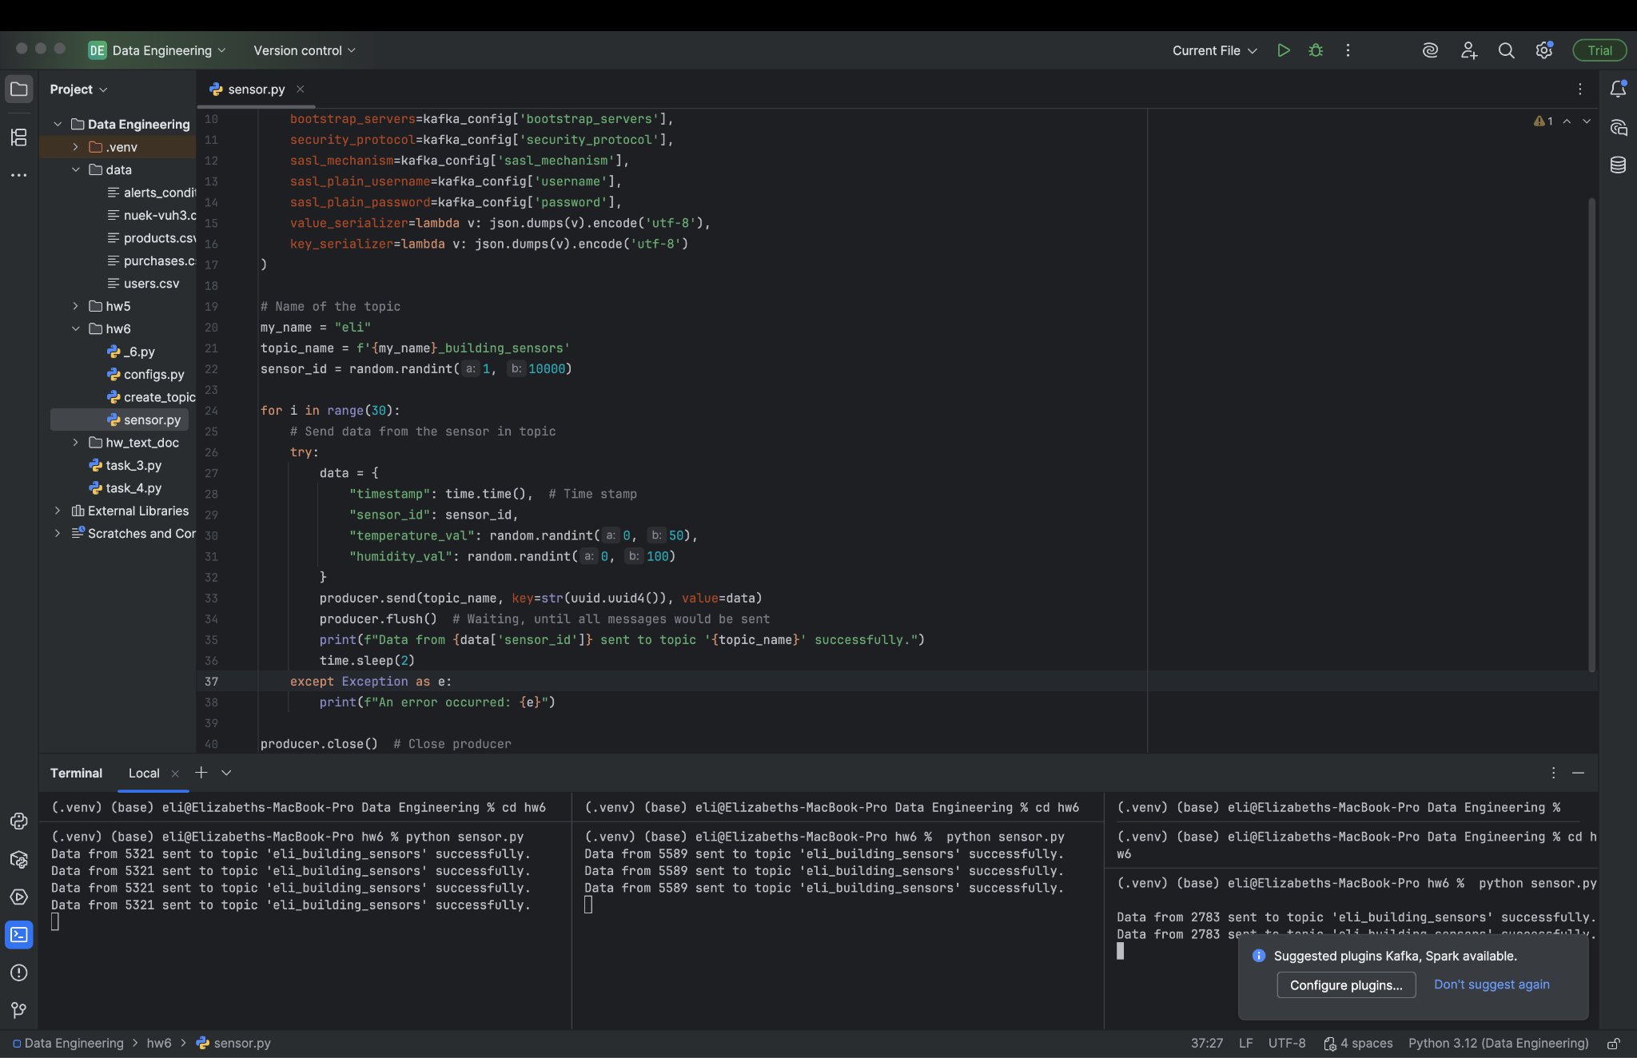
Create 3 topics: eli_building_sensors_1, eli_temperature_alerts_1, eli_humidity_alerts_1. Create an imitation of the sensor job and send random data (temperature and humidity) to topic eli_ building_sensors_1. Run 3 sensors and get logs that data was successfully sended.

Part 2
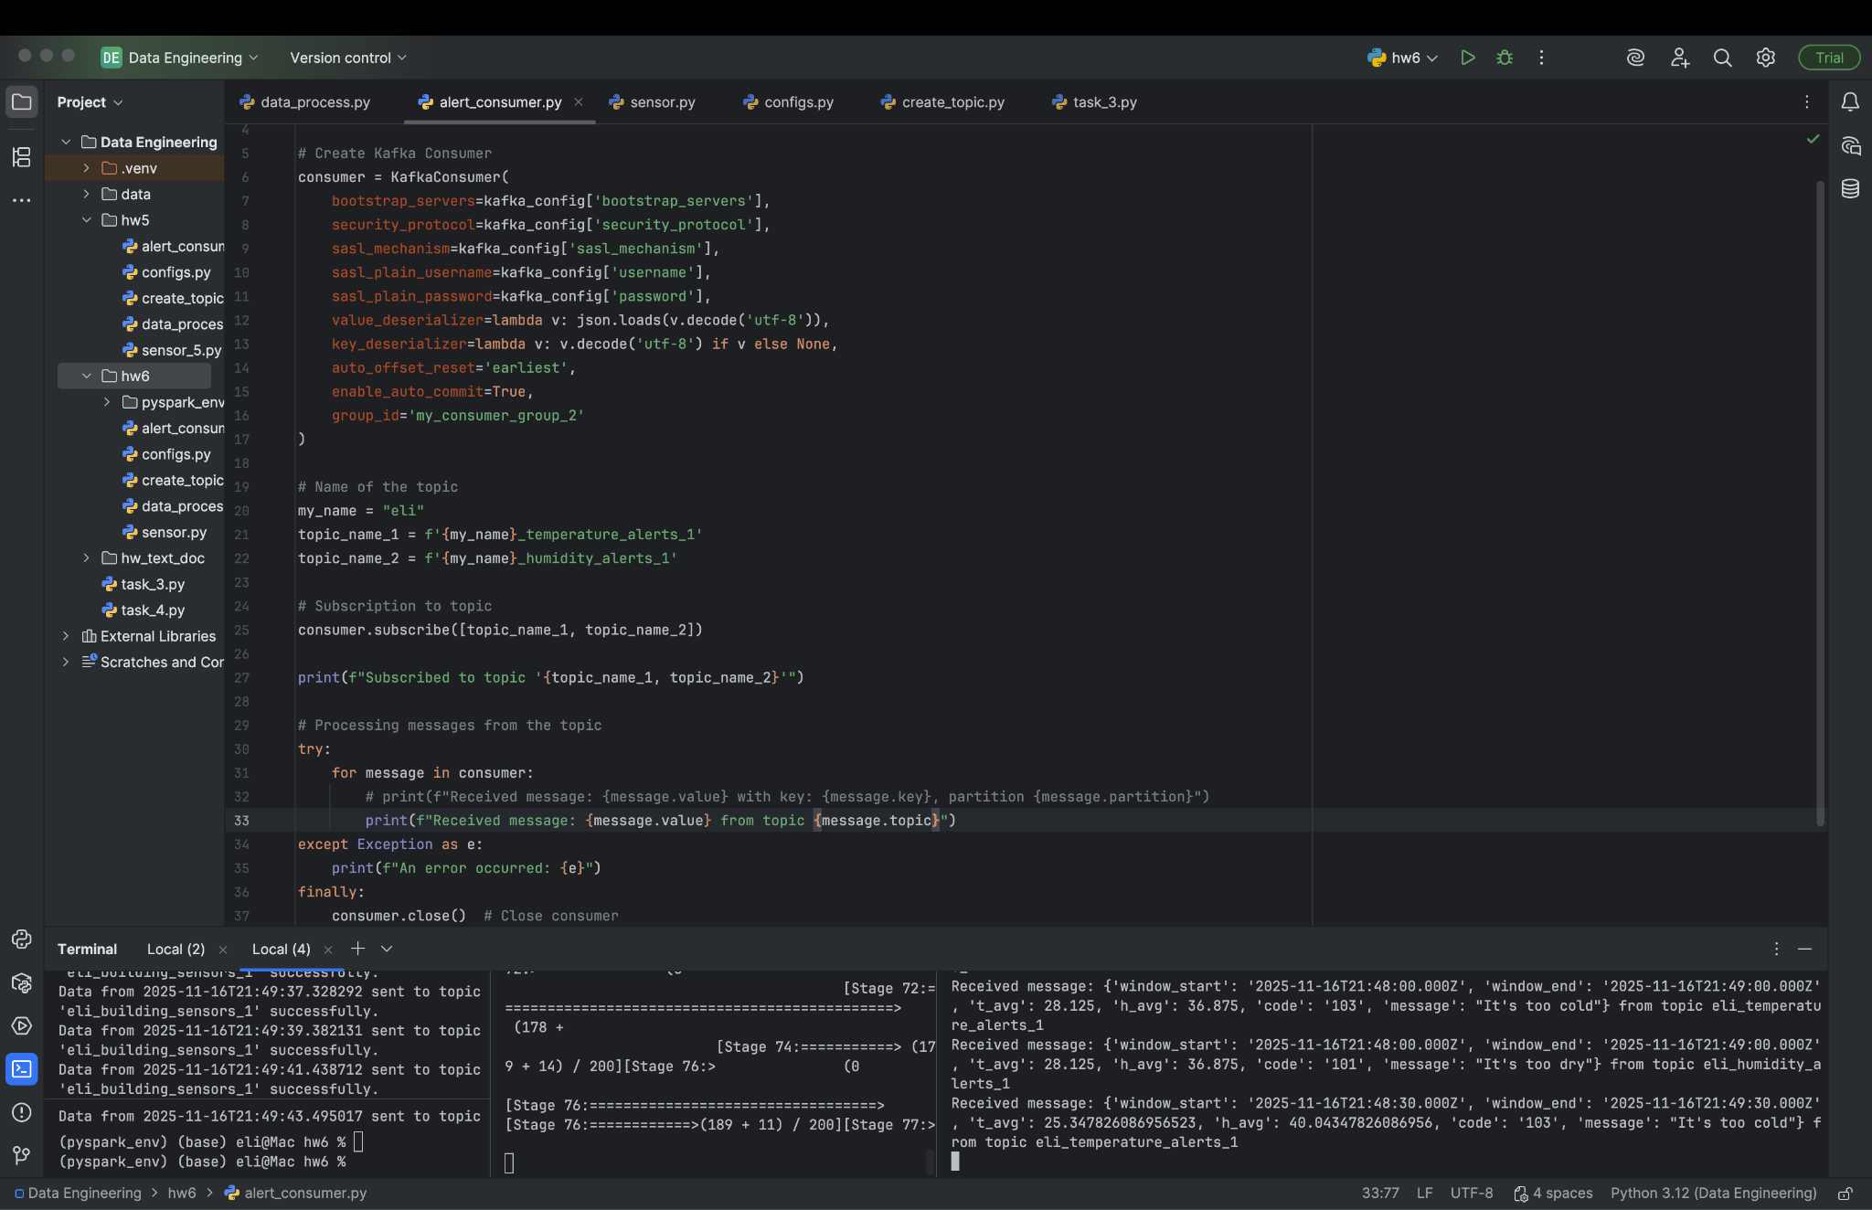
After aggregation of data and getting avg temperature and humidity, setting of alert was done by using data in csv file. Create subscriptions to topics eli_temperature_alerts_1 and eli_humidity_alerts_1, read and print data about these messages.

